Test Project Module 3
(Packaging)

Submitted by: Group 3

Ahmed Al-Harassi (OM)
Chun-Liang Lin (TW)
Anne Grandt (NO)
Vivian de Oliveira Preto (BR)
Sarah Jones (AU), Patricia Dupuis (FR)
Lars Ake Flodmark (SE)

Member Country: OM, TW, NO, BR, AU, FR, SE

Contents
This Test Project proposal consists of the following documentation/files:
- 1. WSC2013_TP40_MODX_PRE_EN.doc
- 2. WSC2013_TP40_MODX_PRE (folder)

Introduction
The company, “Teas of the World” manufactures traditional and herbal teas from different regions of the world. It selects the best teas from the most prestigious plantations. The “Teas of the World” company has been slowly perfected over time. They believe that tea, like wine — requires meticulous care in it’s brewing process and is a ritual. The brewing process of tea is said to be associated with love and friendship.

The “Teas of the World” brand is over 300 years old and has a strong history associated with its company name. The brand has created a dynasty where successors inherit the talent of their elders and follow in their footsteps. Aesthetics, elegance and the pursuit of perfection are the aims of “Teas of the World”.

“Teas of the World” are international leaders in the art of herbal teas. They offer products from all regions of the world, which links them to a culinary knowledge that enhances the taste while using their own basic principles and methodologies: “Teas of the World” embraces the art of brewing and enjoying tea and regards it as a "spiritual drink."

“Teas of the World” has established itself over the years as being renowned as a sensual, cultural and joyful brand. They have succeeded with this through their combinations of cultural references, aesthetics and flavour combinations. The brand constantly looks toward the future for new innovations and creative tea blends, which they do in their laboratories and out in the tea-fields

To develop the brands range, the company “Teas of the World” want to market a new line of "sensorial tea products". They are aiming this tea at tea drinkers between the ages of 20-50 years all over the world that appreciate a healthy lifestyle as these teas are guaranteed to be 100% organic.

perusahaan " Teas of the World " memproduksi teh tradisional dan teh herbal dari berbagai daerah di dunia. Ini memilih teh terbaik dari perkebunan paling bergengsi. Perusahaan "Teas of the World" telah perlahan-lahan disempurnakan dari waktu ke waktu. Mereka percaya bahwa teh, sama seperti anggur - membutuhkan perawatan teliti dalam proses pembuatan bir dan merupakan sebuah ritual. Proses pembuatan teh dapat disamakan dengan cinta dan persahabatan.
merek "Teas of the World" adalah lebih dari 300 tahun dan memiliki sejarah yang kuat terkait dengan nama perusahaan. Merek tersebut telah menciptakan sebuah dinasti dimana penerus mewarisi bakat orang tua mereka dan mengikuti jejak mereka. tujuan " Teas of the World " adalah estetika, keanggunan dan mengejar kesempurnaan.
" Teas of the World " adalah pemimpin internasional dalam seni teh herbal. Mereka menawarkan produk dari seluruh wilayah di dunia, yang menghubungkan mereka dengan pengetahuan kuliner yang meningkatkan rasa saat menggunakan prinsip-prinsip dasar mereka sendiri dan metodologinya: " Teas of the World " mencakup seni pembuatan bir dan menikmati teh dan menganggapnya sebagai " minuman rohani. "
" Teas of the World " telah menempatkan dirinya selama bertahun-tahun yang terkenal sebagai merek sensual, budaya dan menyenangkan. Mereka telah berhasil dengan ini melalui kombinasi referensi budaya mereka, estetika dan rasa kombinasi. Mereka terus-menerus menuju ke arah masa depan untuk inovasi baru dan campuran teh kreatif, yang dilakukan di laboratorium mereka dan keluar perkebunan teh
Untuk mengembangkannya, perusahaan " Teas of the World " ingin memasarkan produk baru " sensorial tea products ". Mereka mempunyai target kepada peminum teh antara usia 20-50 tahun di seluruh dunia yang menghargai gaya hidup sehat dan dijamin 100% organik.

Description of project and tasks
You are required to create:

1. A logo for the “Sensorial Tea” line of products
2. An outer cardboard (Karton) package that contains (mengandung) the three tea varieties inside
3. Three labels (stickers) — One for each of the tea varieties (variasi)

Task 1: Logo Creation

You are required to create a logo for the tea range: “Sensorial Tea” (capital or lower-case according to your design). The name must be clear and readable. The proposed design should be adaptable to different blends of tea. You must use the text in Appendix 1.1

Technical Specifications:
• Trapping: 0.1 mm (if necessary)
• Printing: Offset
• Native File format: EPS or AI
• File creation: Vector only
• Colours:
- One version in 2 x Pantone Uncoated Colours
- One version in CMYK

Electronic Files:
In a folder named Logo:
• One native version of the Pantone logo
• One PDF version of the Pantone logo
• One native version of the CMYK logo
• One PDF version of the CMYK logo

Printed Files:
• The Pantone logo and the CMYK logo will be printed on an A4 sheet side-by-side (bersebelahan)
(each logo to be no larger than 14cm in it’s largest dimension)

Task 2: Cardboard Package

The design of the package should convey an ecological and natural feel(Desain paket harus menyampaikan nuansa ekologi dan alami.).
You must use at least two or more of the images provided in Appendix 2.3.
You may manipulate the images according to your design.
You may create any other elements not supplied.
You must create a working die-line for the package, which will be large enough to contain the three supplied clear plastic bags of tea.
You must use all text in Appendix 2.1 and all files in Appendix 2.2.
Your die-cut should be fully functional and practical and indicate all glue, cut and fold lines.

Technical specifications:
• Stock: Uncoated card 230gsm in SRA3 size
• Bleed (if necessary): 3 mm
• Colours: CMYK + Die-line plate
• Image resolution: 250 - 300dpi placed at 100%
• ICC Profile for images:
- CMYK: Uncoated FOGRA29 (ISO 12647-2:2004)
• Glue: You may use a maximum of 3 glue areas
• Window: Optional according to your design
• Ink Density: CMYK Maximum of 350%
• PDF File Format: PDF/X-4:2008
• Native File format: INDD, EPS or AI
• Raster images: tiff, psd or eps for raster images. Note: you MUST NOT embed the raster files

Packaging elements — All elements must be included in your package design:
• Logos to be included (These can be found in Appendix 2.2):
- Teas of the world (to be used at least once in the design, but you may use it more than once)
- Sensorial Tea (to be used at least once in the design, but you may use it more than once)
- PEFC
- FSC
- Recycle
• EAN 13 bar code in 100% black and 30mm wide
• All Supplied text
• At least two of the provided images

Electronic Files:
In a folder named Package:
• 1 print ready PDF/X-4:2008 including ICC profile, die-line, bleed, colour bars and registration marks
• All working files

Printed Files:
• 1 colour printout cut and folded for presentation assembled in 3D (Printed at 100% on SRA3)
• 1 colour printout mounted on the board provided (including the die-line) (Printed at 100% on SRA3)

Task 3: Labels (Stickers)

The design of the three labels (stickers) should convey an ecological and natural feel (menyampaikan nuansa ekologi dan alami).
You must use at least one of the images provided on the label design from Appendix 2.3.
You may manipulate the images according to your design.
You must include the Sensorial Tea Logo and The Teas of the World Logo.
You may create any other elements not supplied.
You must create the die-line for the labels.
You must use all text in Appendix 3.1

Technical specifications:
• Size: Each label must not exceed a maximum size of 50mm x 50mm plus bleed
• Stock: White uncoated sticker (adhesive) paper 150gsm in A4 size
• Bleed (if necessary): 3 mm
• Trapping (if necessary): 0.1 mm
• Colours: 2 x Pantone Uncoated Colour Logo + CMYK for all other elements + Die-line plate
• Die-line: may be the same shape or a different shape for each label,
• Image resolution: 250 - 300dpi placed at 100%
• ICC Profile for images:
- CMYK: Uncoated FOGRA29 (ISO 12647-2:2004)
• Ink Density: CMYK Maximum of 350%
• PDF File Format: PDF/X-4:2008
• Native File format: INDD, EPS or AI
• Raster images: tiff, psd or eps for raster images. Note: you MUST NOT embed the raster files

Label elements — All elements must be included in your label design:
• Logos to be included:
- Teas of the world logo for each label (supplied) (to be used at least once in each design,
but you may use it more than once)
- Sensorial Tea logo for each label (to be used at least once in the design, but you may use it more than once)
• All Supplied text as per Appendix 3.1 text file, one section of text for each label design

Electronic Files:
In a folder named Labels:
• 3 Print ready PDF/X-4:2008 files including die-line, bleed, colour bars and registration marks
(one for each design)
• 1 A4 PDF that displays all three designs on the one page
• All working files

Printed Files:
• 1 colour printout, cut and stuck onto the plastic bags for presentation and inserted into the 3D package
(All three designs printed on one A4 sheet)
• 1 colour printout mounted on the board provided (including the die-line and all three designs with bleed
printed on one A4 sheet)

When Printing:

To avoid confusion between the candidates include your competitor number in the upper right corner of your print sheet

MARKING SCHEME

A. Creative process — Subjective /2
A.1 ideas and originality (package, logo & labels) 0.75
A.2 understanding the target market (package, logo & labels) 0.75
A.3 unity and relationship between all tasks (package, logo & labels) 0.50

B. Final design — Subjective /8
B.1 quality of the visual composition (package, logo & labels) 1.00
B.2 quality of the typography (package) 1.00
B.3 quality of the typography (logo & labels) 1.00
B.4 quality of the colours — choice, balance, harmony (package) 0.75
B.5 quality of the colours — choice, balance, harmony (logo & labels) 0.75
B.6 creativity of the package shape and labels 1.25
B.7 functionality and usability of the package shape 0.75
B.8 creativity of other design aspects — vector and raster elements 0.75
B.9 quality of the mounted presentation and the 3D assembly 0.75

C. Computer usage — Objective /4
C.1 resolution of images as specified in the task 0.50
C.2 image or element dimensions as specified in the task 0.50
C.3 final dimensions of layout as specified in the task (logo & labels) 0.50
C.4 all required and no additional text are present in the tasks 0.50
C.5 all required elements are present in the tasks 0.75
C.6 Ink density as specified in the tasks 0.50
C.7 die-line supplied as specified in the tasks 0.75

D. Manual abilities — Objective /2
D.1 mounting printouts on board for presentation 0.50
D.2 supply of printouts 0.50
D.3 assembling in 3d — package assembled and stickers applied 1.00

E. Knowledge of the printing industry — Objective /4
E.1 bleed value applied in pdf as specified in the task (package) 0.75
E.2 bleed value applied in pdf as specified in the task (labels) 0.50
E.3 printers marks supplied as specified in the task (labels and package) 0.50
E.4 trapping value applied in illustrator file as specified in the task (logo) 0.50
E.5 trapping value applied in illustrator file as specified in the task (labels) 0.75
E.6 spots and cmyk colours in pdf file as specified in the task 0.75
E.7 package design faces correct when assembled 0.25

F. Saving and file format — Objective /5
F.1 all files saved in the correct format specified in the task 0.75
F.2 icc profile applied in pdf as specified in the task (package) 1.00
F.3 icc profile applied in pdf as specified in the task (labels x 3) 0.75
F.4 saving in a specified pdf format as required in the task 1.50
F.5 final production folder saved as required in the task 1.00

Total = 25 marks per module (objective 15 + subjective 10)

OTHER

Appendix 1.1

Appendix_1.1.rtf:

Sensorial Tea

Appendix 2.1

Appendix_2.1.txt:

Best before date: 10.10.2015
Production date: 03.05.2013

The “Teas of the World” brand is over 300 years old and has a strong history associated with its company name. Our brand has created a dynasty where successors inherit the talent of their elders and follow in their footsteps. Aesthetics, elegance and the pursuit of perfection are our aims. Our blends expertly balance various teas and herbs with sweet flavours.
Welcome a weary stranger or transport you to the bustling alleyways all around world.

The Sensorial Tea range is an innovation in terms of taste and blend. These teas are guaranteed to be 100% organic.

Instructions
Rinse pot with boiling water to bring out the tea’s flavour. 1. Add loose tea according to your strength preference. 2. Add 3 teaspoons of sugar for a more traditional taste. 3. Pour in boiling water and leave for 2 – 3 mins. 4. Drink this tea without milk. 5. Stop what you are doing and savour the moment.
Use fresh water. Water left in the kettle loses vitality and makes the tea flavour not as vibrant.

PO BOX 432, OX90 9JK, England Tel: +44 (0) 2013 786 678 info@teasoftheworld.uk
Blended and packed in the UK.
We share your passion for fine teas and would love to hear any feedback or suggestions you may have.

3x30g

Meditation Tea
For calming and relaxing the body and mind
Lemongrass, Passionflower, Chamomile & Lavender

Uplifting Tea
For happiness and energising the spirit
Ginseng, Rooibos Tea, Blackcurrants, Goji Berries & Aloe Vera

Concentration Tea
For concentration and mental vigour
Green Tea, Basil, Blueberries, Rosemary & Chrysanthemum

Appendix 2.2

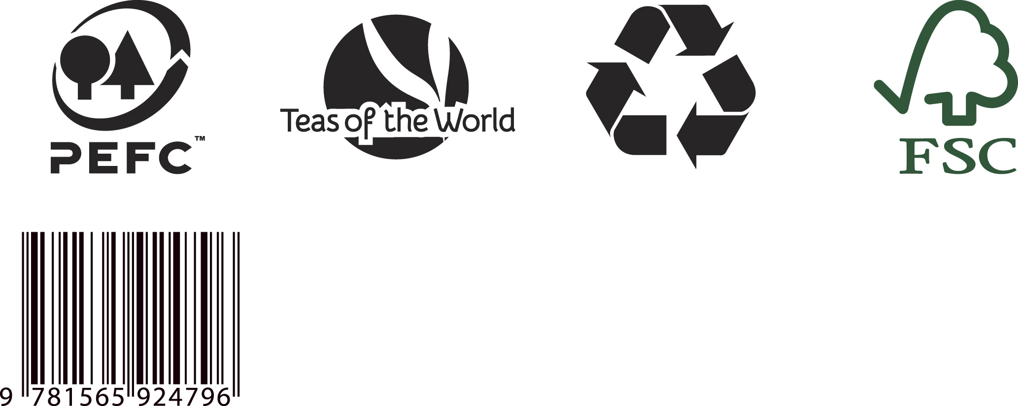
Appendix 2.3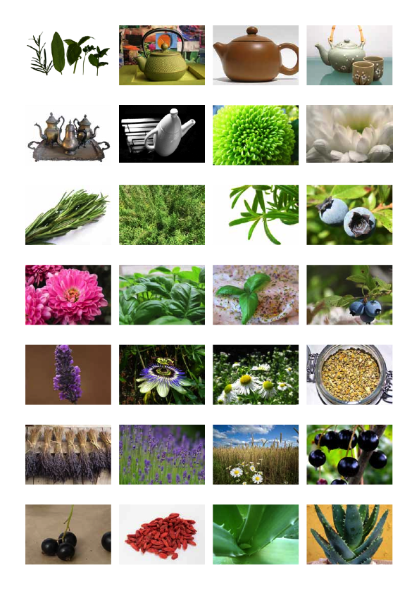

Appendix 2.3 (continued)

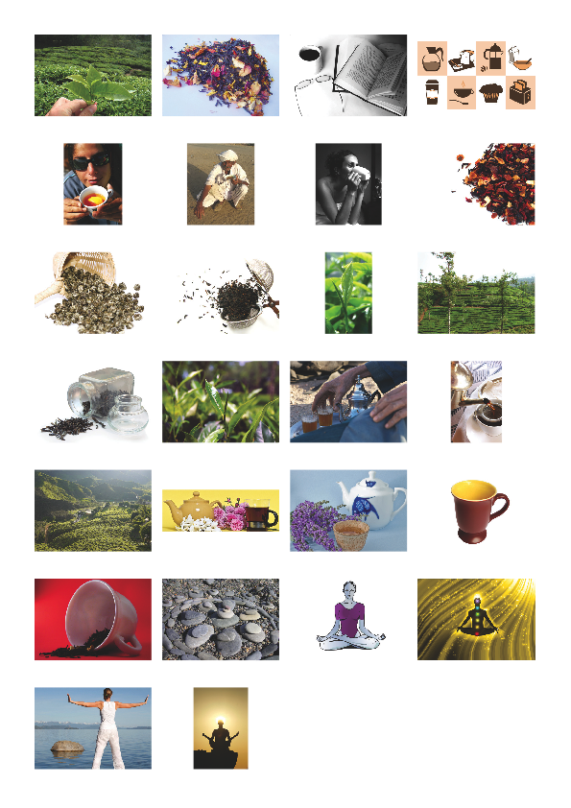
Appendix 3.1

Appendix_3.1.txt:

Label 1

Sensorial Tea Range: Teas to alter your body, mind and spirit

Meditation Tea
For calming and relaxing the body and mind
30g

Label 2

Sensorial Tea Range: Teas to alter your body, mind and spirit

Uplifting Tea
For happiness and energising the spirit
30g

Label 3

Sensorial Tea Range: Teas to alter your body, mind and spirit

Concentration Tea
For concentration and mental vigour
30g

